Assignment – 4

Create a VPC,Public subnet,Route Table,Route Table association within cloud formation Template.

CODE: Save in .yml(YAML) file

CODE:

AWSTemplateFormatVersion: "2010-09-09"

Resources:

  MyVPC:

    Type: "AWS::EC2::VPC"

    Properties:

      CidrBlock: "10.0.0.0/16"

      EnableDnsSupport: "true"

      EnableDnsHostnames: "true"

      Tags:

        - Key: "Name"

          Value: "My VPC"

  MyPublicSubnet:

    Type: "AWS::EC2::Subnet"

    Properties:

      VpcId: !Ref MyVPC

      CidrBlock: "10.0.1.0/24"

      AvailabilityZone: !Select [0, !GetAZs ""]

      Tags:

        - Key: "Name"

          Value: "My Public Subnet"

  MyInternetGateway:

    Type: "AWS::EC2::InternetGateway"

    Properties:

      Tags:

        - Key: "Name"

          Value: "My Internet Gateway"

  MyInternetGatewayAttachment:

    Type: "AWS::EC2::VPCGatewayAttachment"

    Properties:

      VpcId: !Ref MyVPC

      InternetGatewayId: !Ref MyInternetGateway

  MyRouteTable:

    Type: "AWS::EC2::RouteTable"

    Properties:

      VpcId: !Ref MyVPC

      Tags:

        - Key: "Name"

          Value: "My Route Table"

  MyRoute:

    Type: "AWS::EC2::Route"

    Properties:

      RouteTableId: !Ref MyRouteTable

      DestinationCidrBlock: "0.0.0.0/0"

      GatewayId: !Ref MyInternetGateway

  MySubnetRouteTableAssociation:

    Type: "AWS::EC2::SubnetRouteTableAssociation"

    Properties:

      SubnetId: !Ref MyPublicSubnet

      RouteTableId: !Ref MyRouteTable

Create stack

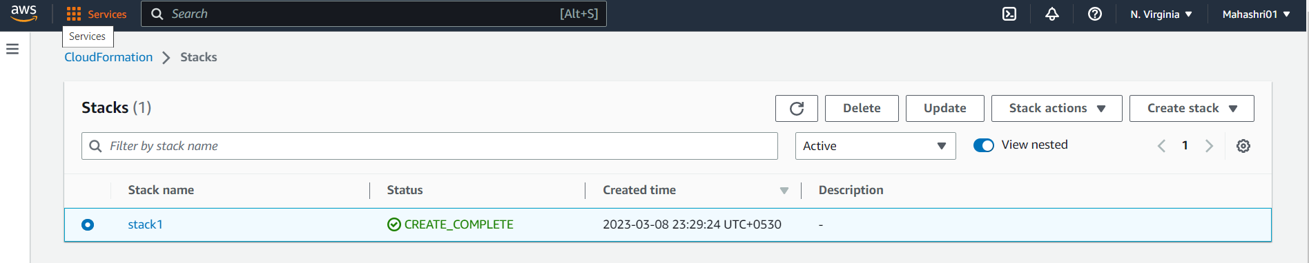

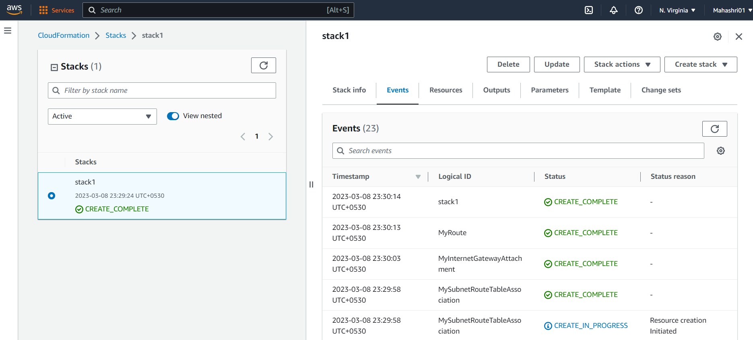

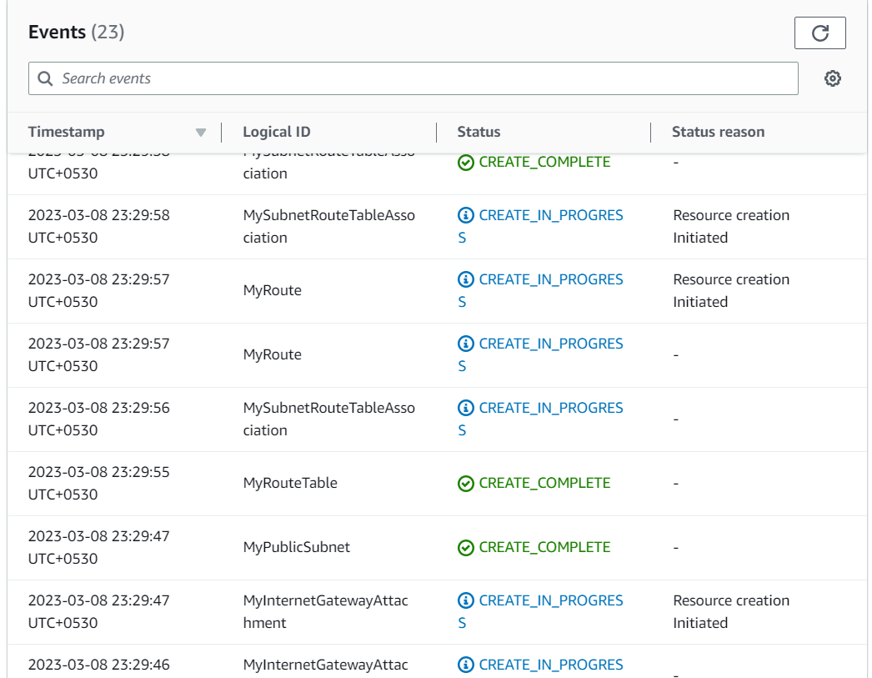

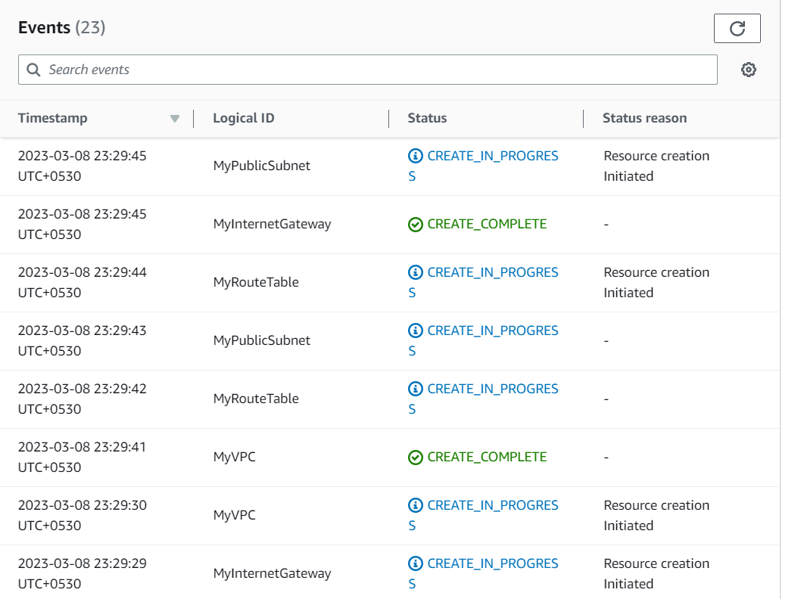

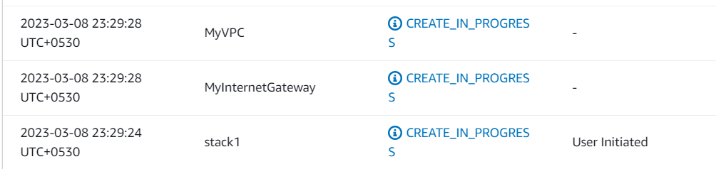

MY VPC is created

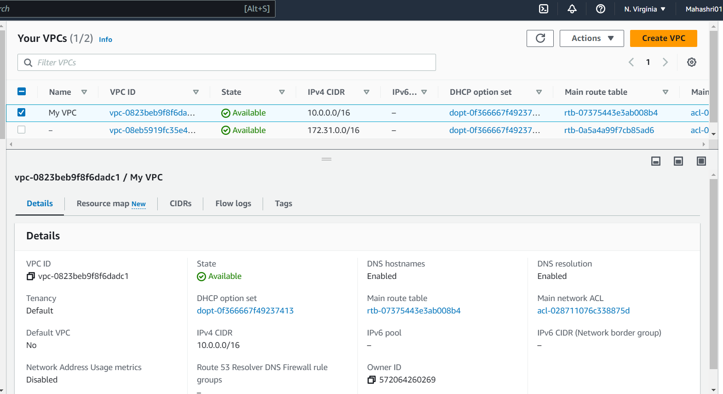

My Public subnet is created

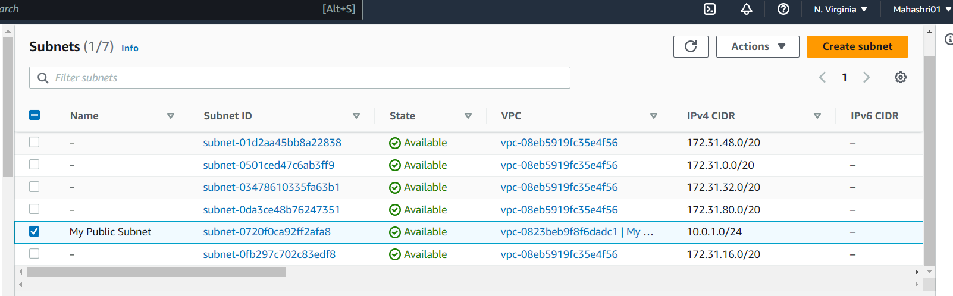

My Route Table is created

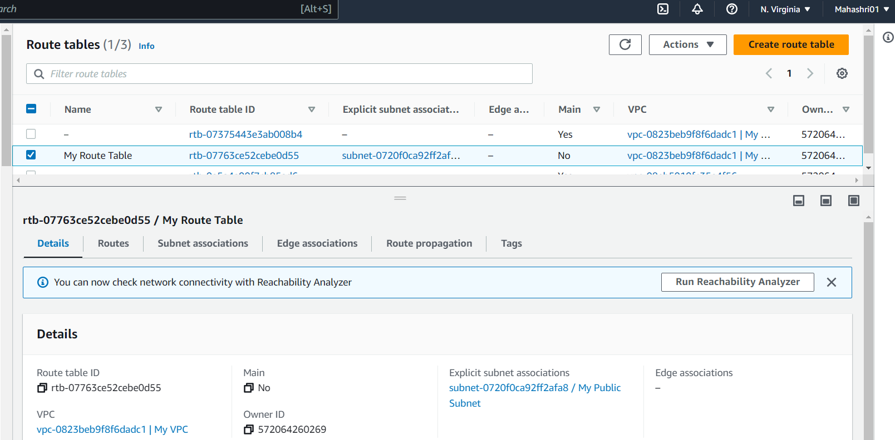

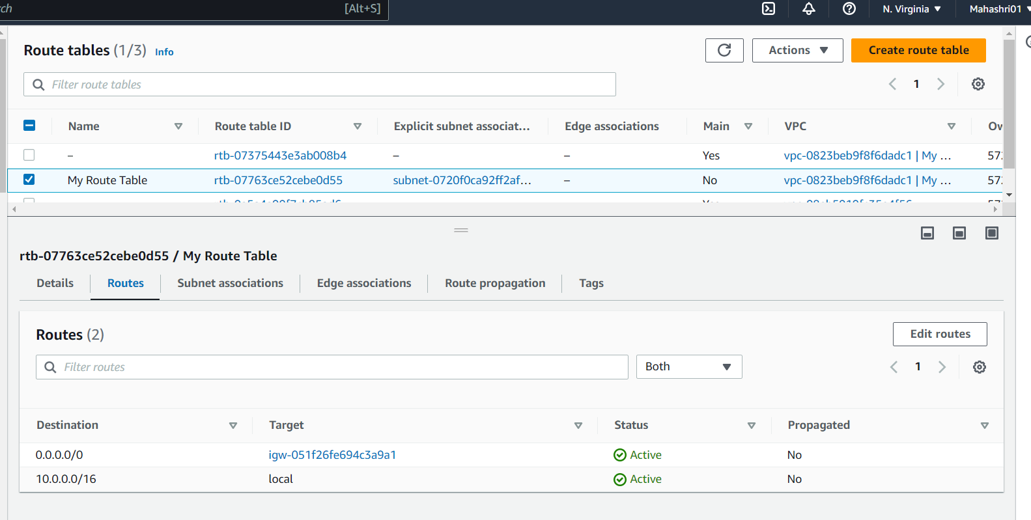My Internet Gateway is created and attached to VPC

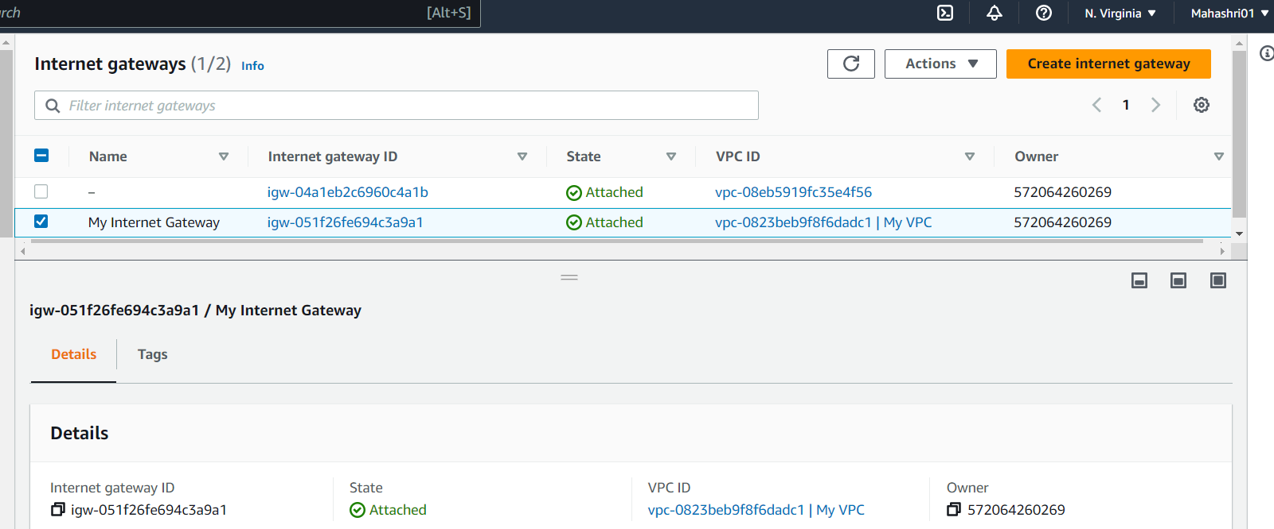

My Route Table subnet association

